IMPLEMENTION OF A FUZZY INFERENCE SYSTEM

Name: Sunmathi.S

Roll no: 241801283

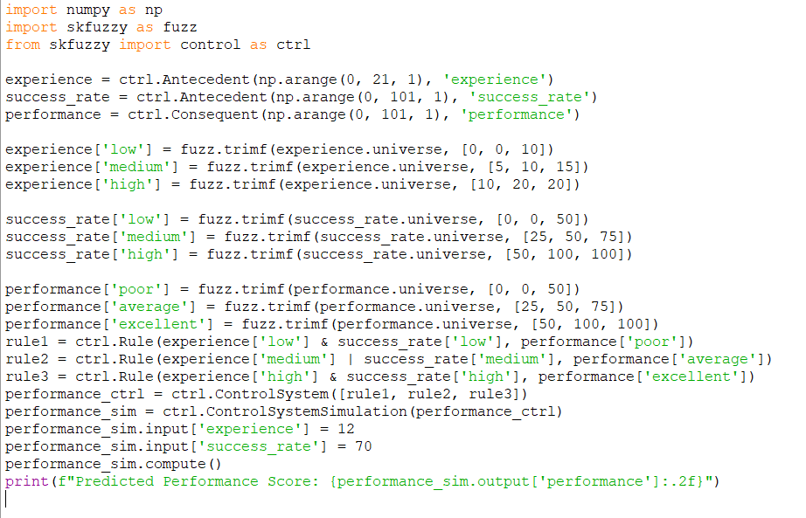

Output:

